**Technology changes are Best or worst?**

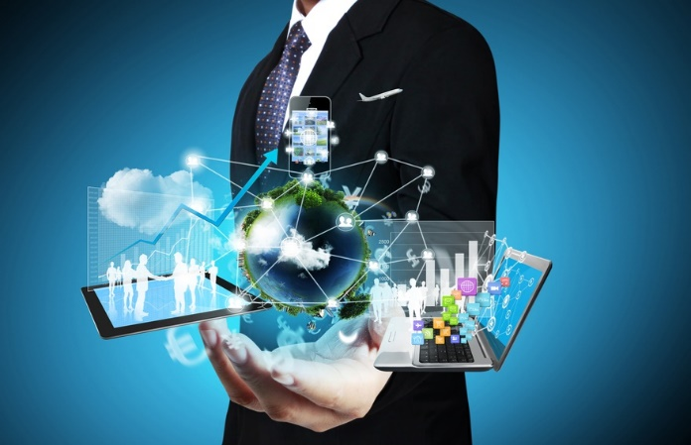

Having a glimpse of the technical trends in the past couple of years, there have been several advancements in the field of technology.  Some changes turned out to be a boon for the industry while others proved to be unproductive. In some way or the other Technology Is Shaping Our World. The pace of technological change is rapidly accelerating & these technologies have changed our lives before we even realized it.

Talking of the advantages of technology, it not only reduces human labor but also saves time and effort. For instance, the use of smartphones has changed our lives to such a great extent that we genuinely have to depend on them for every little task, be it looking up a contact or simple calculation. Other significant innovations in technology have enabled us to broaden our horizons and envision a whole new futuristic world.

Tesla Hyperloop by Elon Musk, the most hyped tech topic of now would prove to be a massive revolution in technology if turns out to be a success. Another amazing innovation is The emergence of AI –especially in the form of Alexa (Amazon’s smart voice recognition) and Google Assistant. Samsung Bixby is another example. Samsung phones offer a dedicated assistant with integrated voice recognition and system controls.

Cloud-based AI services like Amazon, Google, IBM and Microsoft, which are all working on increasing access to machine learning and artificial neural network technology, in order to make it more affordable and easy to use. Doctors and scientists are using technology to tackle problems that once seemed insurmountable.

The truth, however, is that many of the emerging tech fields still have a really long way to go until they have been proven to be safe and are affordable. The dark side of the technological revolution is that, it being a crucial part of existence in contemporary world, has many repercussions too.

Easy and on time availability of resources over the web and ‘On-Demand Everything’ has made people Less Patient. Also, more dependence on Tech devices Leads to Less Creative Thinking in humans.

So there is long way to go in the arena of technology to overcome these shortcomings and benefit maximum from the technology that we are surrounded by.